ALAGANG BARAS: A WEB-BASED LIVESTOCK MANAGEMENT SYSTEM FOR THE OFFICE OF AGRICULTURE IN BARAS CATANDUANES

______________________________

A Capstone Project
Presented to the Faculty
of the College of Information and Communications Technology
Catanduanes State University
Virac, Catanduanes

In Partial Fulfillment of the
Requirements for the Degree
Bachelor of Science in Information Systems

______________________________

Christian Jay V. Vargas
Mark Allen V. Ignacio
Analyn V. Omadto
John Paul G. Torres

TABLE OF CONTENTS

TABLE OF CONTENTS ii
LIST OF FIGURES iv
LIST OF TABLES v
CHAPTER 1: INTRODUCTION 1
Project Context 1
Purpose and Description 3
Objectives 5
Scope and Limitations 7
Definition of Terms 8
Conceptual Framework 10
CHAPTER 2: REVIEW OF RELATED LITERATURE/SYSTEMS 15
Synthesis 18
CHAPTER 3: TECHNICAL BACKGROUND 21
Hardware Requirements 21
Software Requirements 23
Data Requirements 24
User Requirements 26
CHAPTER 4: DESIGN AND METHODOLOGY 28
Requirements Analysis 29
Requirements Documentation 31
Design of Software, Systems, Product and/or Processes 36
Development and Testing 50
Data Gathering Procedure 53
Respondents of the Study 54
Statistical Tool 55
REFERENCES 57
A. Books ....................................................................................................................58
B. Journals/Conferences ............................................................................................58
C. Websites ................................................................................................................59
D. Others Sources ......................................................................................................59

LIST OF FIGURES

Figure 1. Conceptual Framework 12
Figure 2. Use Case Diagram 37
Figure 3. Context Diagram 39
Figure 4. Data Flow Diagram Level 1 40
Figure 5. Existing Process Swimlane 42
Figure 6. Process Swimlane 43
Figure 7. Entity-Relationship Diagram 45
Figure 8. System Architecture 47
Figure 21. Agile Methodology 50

LIST OF TABLES

Table 1. Hardware Requirements 9
Table 2. Software Requirements 10
Table 3. Data Requirements 10
Table 4. User Requirements 26
Table 5. Functional Requirements 32
Table 6. Non-Functional Requirements 34
Table 7. Respondents of the Study 54
Table 4. Likert Scale 56

CHAPTER 1
INTRODUCTION

Project Context
Livestock farming is a vital component of livelihood in Barangay Paniquihan, Baras, Catanduanes, as it contributes not only to household food supply but also to income generation and the stability of the local economy. To support livestock owners, the Municipal Agriculture Office (MAO) implements programs such as livestock profiling, vaccination campaigns, and animal health monitoring. However, these initiatives still rely heavily on manual processes. At present, barangay coordinators record livestock ownership and health updates in logbooks, often based on verbal or handwritten reports from farmers. These reports are consolidated and submitted in paper form to the MAO, where in some cases they are encoded into Microsoft Excel.
This system presents several challenges. The reporting process is slow due to multiple layers of consolidation before reaching the municipal level, which delays the availability of updated data. Records are often inconsistent and incomplete because of the absence of a standardized format, while paper-based documentation is highly vulnerable to loss or damage, particularly during typhoons and other calamities common in Catanduanes. The lack of a centralized database also prevents veterinarians, agricultural officers, and barangay coordinators from accessing real-time information, which is critical during disease outbreaks. Monitoring vaccination schedules and animal health histories becomes difficult, increasing the risk of livestock mortality and lowering productivity. Inaccurate records further complicate the distribution of government assistance such as vaccines, feeds, and profiling, as the basis for allocation is not always reliable.
Despite initial efforts, such as encoding data into spreadsheets and limited national-level pilot projects exploring digital monitoring in agriculture, these measures remain fragmented and have not been fully implemented in rural municipalities like Baras due to financial, infrastructural, and technical constraints. This situation underscores the urgent need for a more integrated and sustainable solution.
Information and Communication Technologies (ICT) are widely recognized as effective tools for advancing economic and social development, even benefiting those without direct access (Mekonnen et al., 2012). In agriculture, barangay coordinators serve as intermediaries between farmers and the MAO (Blum et al., 2009). Their duties include livestock profiling, vaccination monitoring, and providing technical support to farmers—functions that are essential to sustaining productivity and preventing disease outbreaks. However, these responsibilities are constrained by manual documentation and reporting. With the integration of ICT, coordinators and MAO staff can perform their roles more effectively through digitized records, streamlined communication, and timely interventions (Davis, 2009).
In the Philippine setting, the Department of Agriculture (DA) has consistently promoted the use of digital platforms to strengthen agricultural services and improve livestock health management. Studies have shown that disease outbreaks such as African Swine Fever (ASF) could have been minimized with better monitoring systems and real-time reporting (Villanueva, 2020). By implementing a web-based livestock management system, agricultural offices can centralize data collection, monitor livestock conditions, and quickly disseminate important information to farmers and barangay coordinators. This innovation ensures that data integrity is preserved while enabling faster response to local agricultural challenges (Torres, 2021).
This study proposes the development of ALAGANG BARAS:A Web-Based Livstock Management System to be pilot tested in Barangay Paniquihan. The system is designed to improve livestock profiling, health monitoring and reporting. It will also provide secure access for veterinarians, barangay coordinator, administrators, and MAO staff. Through user-friendly dasboards and mobile features, stakeholders can view, updates, and share informationmore easily. Unlike existing digital systems built for commercial farms, this project is tailored to the needs of small rural communities, combining profiling, health tracking, and QR code technology for sustainable livestock management.

Purpose and Description
The purpose of Alagang Baras: A Web-Based Livestock Management System is to help local farmers and livestock raisers in Baras especially in Barangay Paniquihan their animals in a simpler and more organized way. Instead of relying on notebooks and manual records, the system provides an online platform where they can keep track of important information such as animal health monitoring and Livestock Profiling. By making record-keeping faster and easier, the project hopes to lessen the workload of farmers, veterinarian, municipal agriculture office, reduce errors, and give them better access to information that will help improve their livelihood and support the growth of the local farming community. Alagang Baras is an easy-to-use online system built for veterenarian and Municipal Agriculture Office Staff and Barangay Official (Committee on Agriculture) in the Barangay Paniquihan. It allows them to record and monitor details about their swines, and poultry, including health monitoring and livestock profiling. The system stores all this information in one place, so it can be accessed anytime without the risk of losing records. With this tool, farmers can save time, stay more organized, and make better decisions for their livestock. At the same time, it also helps barangay paniquihan official and agricultural officers in supporting farmers by having a clearer view of the overall livestock situation in Baras.

Objectives
The main objective of this capstone project is to develop Alagang Baras: A Web-Based Livestock Management System. This research primarily aims to provide livestock farmers and the Municipal Agriculture Office (MAO) of Baras, Catanduanes with an effective, efficient, accurate, and reliable livestock management. The system is designed to replace the traditional manual processes of profiling and monitoring livestock records with a computerized, web-based platform. Through this project, the researchers hope to achieve improved livestock profiling, systematic health monitoring, and streamlined data management that will support better decision-making for both farmers and MAO staff.
Specifically, the objectives are the following:
- To develop a web-based livestock management system for pilot implementation at the Municipal Agriculture Office of Baras, Catanduanes.
- To design and implement the system’s core features, including: Livestock Profiling, which captures essential animal information such as species, breed, age, sex, vaccination history, and health records; QR Code Integration, which generates a unique code for each livestock record to provide authorized personnel with instant access to the animal’s complete profile, including ownership and health details; Health Monitoring, which facilitates the recording and tracking of vaccinations, deworming, and medical check-ups to ensure timely animal care; and Data Visualization Tools, which transform livestock health data into visual formats to support effective planning and decision-making.
- To evaluate the effectiveness and quality of the developed system based on ISO/IEC 25010 software quality standards through feedback from end users and technical experts, focusing on:
a. Functional Suitability
b. Performance Efficiency
c. Compatibility
d. Interaction Capability
e. Reliability
f. Security
g. Maintainability
h. Flexibility
i. Safety

Scope and Limitations
The study will be conducted in Barangay Paniquihan, Baras, Catanduanes and will involve the Municipal Agriculture Office (MAO) staff, barangay coordinators, the veterinarian, administrative personnel, and selected livestock owners as participants. It focuses on the development, implementation, and evaluation of ALAGANG BARAS: A Web-Based Livestock Management System, designed mainly for livestock profiling and health monitoring. The system will store and organize essential information such as species, breed, ownership details, age, and health status. Data will be gathered through structured interviews, system testing, and validation of records with the MAO. The required resources include a web development environment, existing livestock records, and internet access to support deployment and testing. The findings are expected to enhance livestock management practices in Barangay Paniquihan and may also serve as a reference for other barangays in Baras that wish to adopt similar systems.
However, the system has certain limitations. It is developed only for Barangay Paniquihan and does not cover other areas. As a web-based platform, it relies on stable internet connectivity and may encounter issues in locations with poor signal. The system is optimized for modern browsers but may have reduced performance on outdated devices. Data accuracy also depends on correct and timely input by authorized personnel, which remains prone to human error. Furthermore, the current version is limited to profiling, health monitoring, QR code generation, and reporting, excluding advanced features such as financial management, automated notifications, and external system integration. While it employs basic security measures, stronger protection against sophisticated cyber threats depends on proper server configurations and maintenance.

Definition of Terms
Administrator someone who manages the overall functionality of the system, including editing, adding, and deleting data.
Agile Development a software development approach applied in creating ALAGANG BARAS, which focuses on incremental improvements, collaboration with stakeholders, and flexible planning based on user feedback and testing.
Barangay Coordinator the designated representative in the barangay responsible for monitoring livestock ownership, collecting data, and reporting updates to the MAO. They serve as intermediaries between farmers and agricultural authorities.
Compatibility the system’s ability to run properly across different web browsers and devices, while allowing possible integration with existing tools used by farmers or the Municipal Agriculture Office (MAO).
Department of Agriculture (DA) the national government agency in the Philippines tasked with promoting agricultural development, ensuring food security, and implementing livestock and crop-related programs, including the adoption of digital systems for improved agricultural services.
Flexibility the capability of the system to adjust to different user needs or operational changes without requiring major redevelopment.
Functional Suitability the extent to which the system performs its intended functions under specific conditions, ensuring that all features operate accurately and as expected, following the standards of ISO/IEC 25010.
Health Monitoring the process of documenting and reviewing the health status of livestock, including illnesses, treatments, and veterinary care, to ensure early detection and proper management of animal health.
Information and Communication Technology (ICT) technological tools and systems that facilitate the collection, storage, processing, and sharing of information. In this study, ICT is applied through a web-based system to digitize livestock records, streamline reporting, and improve decision-making.
Interaction Capability relates to the system’s usability, particularly how efficiently farmers, coordinators, and agricultural staff can use the platform to update records, view reports, and access essential information.
ISO/IEC 25010 an international standard for assessing software quality. It evaluates aspects such as functional suitability, performance efficiency, compatibility, usability, reliability, security, maintainability, flexibility, and safety, ensuring that the system meets recognized benchmarks.
Livestock Management the organized practice of raising farm animals such as cattle, carabaos, goats, pigs, and poultry, which includes monitoring their health, feeding, breeding, and maintaining proper records.
Maintainability the ease with which the system can be updated or modified to address future needs, such as adding new livestock categories or applying changes suggested by users.
Municipal Agriculture Office (MAO) the local government office responsible for agricultural programs, technical assistance to farmers, and livestock-related initiatives at the municipal level.
Office of Agriculture (OA) a national government agency that promotes agricultural development in the Philippines. In this context, it may provide support or endorsement for the wider adoption of the ALAGANG BARAS system.
Performance Efficiency the ability of the system to deliver results effectively in relation to the resources used, measured in terms of response time, processing speed, and system resource utilization.
QR Code a machine-readable code generated for each livestock record in the ALAGANG BARAS system. When scanned, it provides authorized users with quick access to the animal’s complete profile, including ownership details, vaccination history, and health records.
Reliability the system’s consistency in performing livestock management functions over time without unexpected failures, ensuring dependable data access whenever needed.
Safety the system’s ability to operate in a way that prevents harm to users, data, and processes, minimizing risks and ensuring secure handling of information.
Security the capacity of the system to protect livestock data, user accounts, and operational records from unauthorized access or cyber threats, while maintaining confidentiality, integrity, and availability.
Swine Fever (ASF) a highly contagious viral disease affecting pigs, causing high mortality rates and serious economic losses in the swine industry. It does not affect humans but poses a major threat to livestock farmers.
Web-Based Livestock Management System a digital platform that enables farmers and agricultural personnel to manage livestock records through web technologies. It includes features such as data entry, health monitoring, vaccination scheduling, and report generation.

Conceptual Framework
The researchers of this study use an interview, observation and a survey questionnaire in terms of data gathering tools to collect necessary information that will support the development of ALAGANG BARAS: A Web-Based Livestock Management System for the Office Of Agriculture in Barangay Paniquihan Baras CAtanduanes. This study provides a structured guide that directs the research in a systematic and coherent manner. Using the Input-Process-Output (IPO) model, it identifies the necessary inputs, including livestock data, personnel information, and system requirements, which guide data collection. The process component informs the design, development, and implementation of the web-based livestock management system, encompassing data encoding, health monitoring, and report generation. The output component defines the expected results, such as a functional system, accurate records, and timely reports, which serve as criteria for evaluation. This framework is grounded in General Systems Theory (Bertalanffy, 1968), which conceptualizes systems as composed of interrelated components—inputs, processes, and outputs—working together to achieve a common goal.

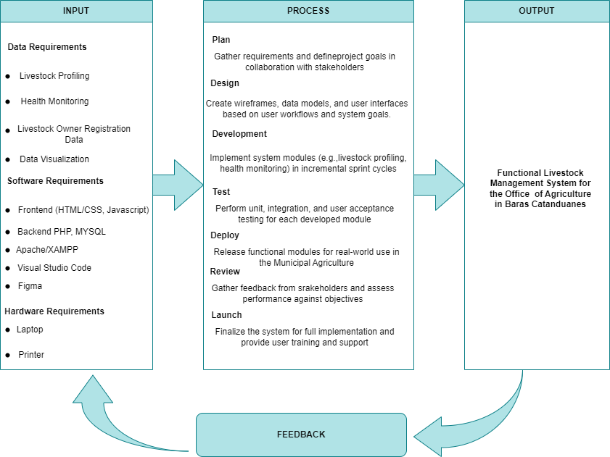
Figure 1. Conceptual Framework

Figure 1 illustrate the conceptual framework of ALAGANG BARAS: A Web-Based Livestock Management System is grounded in the Input-Process-Output (IPO) model, enhanced with Agile methodology and a feedback loop. In the input phase, essential requirements—such as livestock data, personnel information, and system specifications—are collected through interviews, observations, and survey questionnaires to ensure accurate and relevant data for system development. The process phase utilizes Agile methodology to facilitate iterative design, development, and testing of core functionalities, including data encoding, health monitoring, QR code integration, and report generation, thereby promoting continuous stakeholder collaboration and adaptability to changing requirements. The output phase delivers a fully functional system, providing accurate records, timely reports, and improved livestock monitoring, which serve as criteria for evaluating system effectiveness. Finally, a feedback loop enables continuous system refinement by incorporating user input on usability and performance, ensuring the system remains responsive, reliable, and aligned with the operational needs of the Office of Agriculture in Barangay Paniquihan, Baras, Catanduanes.

CHAPTER 2
REVIEW OF RELATED LITERATURE/SYSTEMS

This chapter presents a thematic review of relevant literature to provide a foundation for the proposed Web-Based Livestock Management System. The review focuses on five areas aligned with the project’s core components: (1) web-based livestock health monitoring systems, (2) digital livestock profiling and information management, (3) data visualization and decision support systems, (4) integration of web platforms and system architecture, and (5) challenges, adoption barriers, and research gaps. The synthesis highlights prior work, existing limitations, and how the proposed system contributes to addressing these gaps.

Web-Based Livestock Health Monitoring Systems

Many studies stress how important it is to digitize health records so that diseases can be better prevented and managed. Biggs and Smith (2023) said that standardized digital health records make it easier to make decisions and follow the rules, but they often have problems because the formats aren't always the same. Workneh et al. (2022) showed that electronic systems for reporting livestock health can help find outbreaks faster and lower the cost of surveillance, but they still have problems with usability and data completeness. Mylan and Turner (2023) emphasized that digital treatment records reduce errors and facilitate audits when combined with regulatory databases. A deployment study of a secure cattle health monitoring platform (2024) also showed that encryption and role-based access are very important for protecting sensitive health data. Lastly, FAO (2023) said that centralized registries speed up disease tracking but need international standards for interoperability.

Digital Livestock Profiling and Information Management

Profiling systems are very important for managing herds well. A 2020 review of the use of digital technology in livestock said that relational databases that keep track of animal IDs, productivity, and treatments make it easier to trace animals and make decisions. But when interfaces are hard to use, adoption is harder. PLOS (2024) found that livestock profiles serve as "boundary objects" that connect farmers, veterinarians, and markets, but interoperability issues still exist. Research on Electronic Livestock Health Records (ELHRs) also showed that web-based profiles help with morbidity and mortality analytics and cut down on data loss (Workneh et al., 2022). Commercial software surveys found important profiling modules like breeding, events, and inventory. They also stressed how important it is to be able to import and export CSV files for practical use. Policy reviews also showed that registries that offer web APIs and standardized schemas make it much easier to share data.

Data Visualization and Decision Support Systems

Farmers and veterinarians can use visualization tools to turn complicated data into useful information. Keating et al. (2019) analyzed visualization in agricultural decision support systems, advocating for dashboards equipped with time-series and drill-down functionalities. Frontiers (2023) found that using consistent dashboards made it easier to understand and make decisions about policies in agriculture. A study on interactive visualization tools (Wiley, 2023) found that filters and web-based plotting made it easier for farmers and researchers to work together. MDPI (2022) stressed the importance of user-centered dashboard design, calling for legends that are easy to understand, mobile responsiveness, and localization. The USDA's DAWN and LTAR dashboards showed how mixing maps, charts, and downloadable datasets made things clearer and easier to use.

Global and Local Practices in Livestock Management Systems

Around the world, livestock management systems have evolved by embracing digital traceability tools like RFID, smart tags, and blockchain to enhance disease control, food safety, and market transparency. Australia and the EU have adopted RFID on a national level and centralized databases, while the U.S. is continuing to grow RFID adoption and countries such as Zimbabwe and Malaysia incorporate blockchain and halal-compliant tracking for export requirements. In Asia, adoption is socially and culturally driven, such as in Japan's small-scale farms. Domestically, the Philippines is also adopting digital livestock management through projects like QR-code-based swine monitoring systems, UPLB and PCAARRD's Computer-Aided Remote Expert (CARE) system for pig health, and computerized auction markets with automated weighing and monitoring in Western Visayas. National initiatives such as the PhilAIMIS project seek to consolidate livestock and poultry information into a unified data warehouse that reflects international and domestic drives towards digitalization for efficiency, transparency, and improved animal health management.

Challenges, Adoption Barriers, and Research Gaps

Adoption challenges continue to be a major issue in livestock information systems. According to Elsevier (2020), cost, training, and connectivity are some of the things that make it hard to adopt digital technology. MDPI (2022) said that bad UX and not involving farmers in the design process make it harder for them to get involved. Problems with data quality and labeling (Frontiers, 2023) also make digital systems less reliable. Connectivity studies (WEF, 2023) showed that offline entry and delayed synchronization are good for farms in rural areas. Finally, policy reviews pointed out that the lack of standardized governance and metadata is a major problem.

Synthesis
The literature reviewed reveals an increased international push towards revolutionizing the management of livestock using digital and web-based technologies. Animal health monitoring and disease surveillance studies illustrate the role of digital health records, smart monitoring systems, and web-based surveillance tools in enhancing the documentation of treatment, early detection of diseases, and real-time decision-making (Biggs & Smith, 2023; Mylan & Turner, 2023; Workneh et al., 2022). These technologies minimize dependence on manual documentation and maximize veterinary reactions, with immense potential to protect animal well-being and increase productivity. Concurrently, digital livestock profiling and information management research highlights the importance of central databases and interoperable registries that offer farmers complete animal histories and production information (FAO, 2023; Folio3, 2023). By combining profiling with health and production systems, livestock management platforms enable traceability, transparency, and improved farm-level decisions. This fits into the worldwide trend of embracing animal registries and data-sharing systems to bring agriculture record-keeping into the modern era. A third body of research highlights data visualization and decision support systems. Dashboards and visualizations designed for agriculture help farmers better intuitively understand complex data sets, informing decisions across breeding, feeding, and marketing (Keating et al., 2019; USDA, 2023). Human-centered dashboard design and visual innovation also make agricultural technology more accessible, especially to smallholder farmers, by making it easier to interpret data and communicate clear actions. Web-based platforms also facilitate collaborative farming through connectedness of stakeholders using integrated interfaces. In spite of all these advancements, research has continually reported against adoption and research gaps. Limited digital literacy, organizational costs of implementation, rural connectivity, and resistance to change remain overwhelming challenges (Elsevier, 2020; Frontiers in Veterinary Science, 2023). Though dashboards and profiling systems show great promise, there are gaps in meeting the requirement for inclusivity, scalability, and farmer take-up, particularly in resource-constrained environments. In general, the synthesis uncovers that digital livestock management systems promise efficient solutions for enhancing efficiency, traceability, and decision-making. Yet to harness their full potential lies in mitigating challenges in accessibility, affordability, and usability. These findings serve as the cornerstone for the construction of a web-based livestock management system for Baras, Catanduanes, which aims to merge health monitoring, profiling, decision support, and data-sharing into a friendly platform suitable to the preferences of local farmers. Global and domestic practices in livestock handling both highlight the trend toward digitalization and traceability for enhanced efficiency, disease management, and food safety. Sophisticated technologies such as RFID, blockchain, and centralized databases are applied extensively in nations such as Australia, the EU, and the U.S., while countries such as Zimbabwe and Malaysia innovate these technologies for domestic requirements. In the Philippines, such innovations as QR code-based pig monitoring, CARE systems, and computerized livestock markets indicate attempts at modernizing cattle management that are backed by national initiatives like PhilAIMIS. Generally speaking, international systems offer models that can be scaled, and local practices translate such innovations into accessible means, demonstrating a common appreciation of ICT as being crucial to sustainable cattle management.

CHAPTER 3
TECHNICAL BACKGROUND

This chapter details the technical requirements necessary for the successful implementation and operation of Alagang Baras, the web-based livestock management system designed for the Office of Agriculture in Baras, Catanduanes, with its initial deployment in Barangay Paniquihan. Understanding these requirements is crucial for ensuring system stability, performance, and scalability. The following sections outline the hardware, software, and network specifications needed to support the system’s functionality and accommodate future growth. These requirements are categorized for clarity and ease of understanding.

Hardware Requirements
The following table summaries the essential hardware components required to develop and run the A Web-Based Livestock Management System for the Office Of Agriculture in Baras Catanduanes effectively.

Table 1. Hardware Requirements
Hardware Requirement | Specification | Description
Laptop/Desktop | Intel Core i5 Processor, 8GB RAM, 256GB SSD | Serves as the primary device for developing, accessing, and maintaining the Alagang Baras system, ensuring stable performance for coding, database management, and daily livestock data operations with smooth multitasking and minimal delays
Network Equipment | Router with at least 300 Mbps capability, Ethernet ports, Wi-Fi 5 support | Ensures stable internet connectivity for both development and end-user access, enabling uninterrupted system usage.
Backup Storage | External HDD/SSD with at least 1TB capacity | Stores system backups, archives, and important configuration files to protect against data loss.
Peripheral Devices | Printer, Scanner, QR Code Scanner | Supports operational tasks such as printing official reports and certificates, digitizing physical records for secure storage, and scanning livestock QR tags for efficient identification and monitoring.

Table 1 Hardware Requirements the Alagang Baras web-based livestock management system needs some key hardware to work smoothly during development, initial deployment, and daily use. A laptop or desktop with at least an Intel Core i5 processor, 8GB RAM, and 256GB SSD provides the necessary computing power for development tasks such as system coding, database handling, and testing. These specifications also ensure that end-users can perform daily livestock data operations without delays, guaranteeing smooth multitasking and reliable performance. Reliable network equipment, specifically a router with at least 300 Mbps capability, Ethernet ports, and Wi-Fi 5 support, is required to maintain stable internet connectivity. Since the system relies on web access for data entry, monitoring, and report generation, uninterrupted connectivity is critical for both developers and users in the field. To safeguard data, backup storage in the form of an external HDD or SSD with at least 1TB capacity is needed. This allows system administrators to store system backups, archives, and configuration files, ensuring that data can be recovered in the event of hardware failure, accidental deletion, or other unforeseen issues. Lastly, peripheral devices such as a printer, scanner, and QR Code Scanner, though optional, enhance operational efficiency. A printer supports the generation of official reports, certificates, and livestock records in hard copy format. The scanner enables the digitization of physical documents, making record storage and retrieval more secure and accessible. The QR Code scanner facilitates quick and accurate identification of livestock, ensuring efficient monitoring and data entry within the system. Together, these peripherals strengthen the reliability, accessibility, and efficiency of the Alagang Baras system, allowing both administrators and end-users to maximize its full potential in livestock management.

Software Requirements
This table lists the software tools and platforms needed for the system development and operation of the Web-Based Livestock Management System. .
Table 2. Software Requirements
Software Requirement | Specification | Description
Operating System | Windows 10 or Higher | The operating system that hosts the server and client applications, ensuring compatibility with web-based development tools.
Web Browser | Google Chrome, Mozilla Firefox | Required for users to access the web-based system interface.
Database Management System | MYSQL | Stores and manages all livestock records, user accounts, and system data securely.
Web Server | Apache/XAMPP | Hosts the Alagang Baras application, providing secure and reliable access for multiple users.
Backup & Secuity Tools | Google Drive Desktop, Antivirus | Ensures system files and databases are regularly backed up and protected against data loss or unauthorized access.
Frontend | HTML,CSS, Javascript | Used to design and develop the system’s user interface, ensuring it is responsive and user-friendly.
Backend Language | PHP | Provides the core application logic, processes user requests, and manages data communication between the interface and database.
Prototyping | Figma | Used to create interactive system mockups and design prototypes, allowing developers and stakeholders to visualize the user interface before implementation.
Development tools | Visual Studio Code | Used for writing, editing, and debugging the application code during development.

Table 2 shows that the Web-based Livestock Management System relies on a range of software tools to support its development and operation. Windows 10 or higher serves as the operating system, ensuring compatibility with development tools. Web browsers such as Google Chrome and Mozilla Firefox enable users to access the system interface seamlessly. MySQL functions as the database management system, securely handling livestock records and user data, while Apache/XAMPP acts as the web server to host the application and support multi-user access. To safeguard information, Google Drive Desktop, Antivirus to ensure regular file and database backups. HTML, CSS, and JavaScript are used for the responsive and user-friendly frontend, while PHP powers the backend logic and communication with the database. Figma supports prototyping and interface visualization, while Visual Studio Code provides an efficient environment for writing, editing, and debugging the system’s code. Collectively, these software requirements ensure that the system is reliable, secure, and user-centered.

Data Requirements
This table provides an overview of the main data inputs, their sources, and how they are processed within the livestock management system.
Table 3. Data Requirements
Construct/ Variables | Source of Data | Data Gathering Technique | Instrument | Data Processing
Livestock Identification | Livestock Owners, Barangay Coordinator, MAO Records | Field Visits, Record Review | Livestock Profile Form | Encoded into database, categorized by species, breed, and ownership
Owner Information | Livestock Owners, Barangay Coordinator | Interviews, Survey | Questionnaire | Linked to livestock records for traceability
Health Monitoring Records | Veterinarians, MAO Staff, Barangay Coordinator | Observation, Record Review | Health Log Forms | Recorded in system; analyzed for vaccination schedules and disease patterns
System Evaluation | End-User | Survey, Interviews | Survey Questionnaire | - Mean  - Frequently count  - Percentage
System Access and Security Logs | System Database | System Monitoring | System Access Logs | Analyzed for security breaches, login activity, and access levels
QR Code Identification | System Database (auto-generated per livestock profile) | System Generation & Assignment | QR Code Generator Module | Unique QR codes created, stored, and linked to each livestock profile for quick retrieval

Table 3 The Data Requirements for the Web-Based Livestock Management System, emphasizing their role in maintaining organized and reliable records. Livestock identification data are obtained from livestock owners, Barangay Coordinators, and MAO records through field visits and document reviews. These data are encoded into the system database and categorized by species, breed, and ownership. Owner information is gathered via interviews and surveys using questionnaires, which are directly linked to livestock profiles to ensure accurate traceability. Health monitoring records are collected from veterinarians, MAO staff, and Barangay Coordinators through observation and record reviews, documented in health log forms, and stored in the system for analysis of vaccination schedules, treatments, and disease patterns. The system also generates unique QR codes for each livestock profile, allowing authorized personnel to quickly access ownership and health information, thereby enhancing data accessibility and reliability. Additionally, system evaluation data are obtained from end-users through surveys and interviews and analyzed using statistical methods such as mean, frequency count, and percentage. Finally, system access and security logs are produced from the database to monitor login activity, access levels, and potential security breaches.

User Requirements
This table presents the system modules, their functions, and the roles of users who interact with each module
Table 4. User Requirements
Module | Function | Description | User Role
Dashboard | Overview of the System status | Provides a centralized view of system activities, livestock statistics, and quick access to key functions. | Admin, Staff
Health Monitoring | Tracks health and vaccination records | Records and monitors the health status, vaccination schedules, treatments, and medical history of each animal. | Veterinarian, Barangay Coordinator
Livestock Profiling | Registers and updates livestock records | Allows for the creation, updating, and categorization of livestock profiles, including species, breed, age, and ownership details. Each profile is automatically assigned a unique QR Code for quick identification. | MAO Staff, Barangay Coordinator
Report Generation | Creates system-generated reports | Generates detailed and summary reports on livestock populations, health status, and system usage statistics. | Admin, MAO Staff, Barangay Coordinator
User Management | Manages system users and their roles | Handles registration, role assignment, and access control to ensure secure and authorized system use. | Admin

Table 4 shows the User Requirements for the Web-Based Livestock Management System, explaining the different modules, their purposes, and the roles of the users who interact with them. The Dashboard serves as the main hub, giving a clear overview of system activities, livestock statistics, and quick access to important features. Admins and Staff have full access, while Barangay Coordinators can view relevant information for their area. The Health Monitoring module keeps track of livestock health, including treatments, vaccination schedules, and medical history. Veterinarians mainly handle this module, but Barangay Coordinators assist by entering or verifying data provided by livestock owners. Through the Livestock Profiling module, users can add, update, and organize livestock records by species, breed, age, and ownership, with each record assigned a unique QR code for easy identification. This module is used by both Staff and Barangay Coordinators. The Report Generation module allows the creation of detailed or summary reports on livestock populations, health status, and system usage, accessible to Admins, Staff, and Barangay Coordinators who need local-level insights. Lastly, the User Management module is dedicated to Admins and handles user registration, role assignments, and access control to maintain security and authorized system use.

CHAPTER 4
DESIGN AND METHODOLOGY

This chapter discusses the design and methodology applied in developing ALAGANG BARAS: A Web-Based Livestock Management System for the Office of Agriculture in Baras, Catanduanes, which was first introduced in Barangay Paniquihan. The system was designed with a technical framework that centers on livestock profiling, health monitoring, and the use of QR codes for quick data access. The section describes the overall system structure, its components, and the user interfaces, together with the tools and technologies that supported the development process. It also explains why the Agile methodology was adopted, as it allowed the researchers to work in cycles of planning, designing, testing, and improving the system with direct input from the intended users. By presenting both the design choices and the development process, this chapter shows how the system responds to the difficulties faced by the Office of Agriculture in keeping accurate livestock records, monitoring animal health conditions, and making livestock data more accessible for timely action and informed decision-making.

Requirements Analysis
A requirements analysis was conducted in Barangay Paniquihan to ensure that ALAGANG BARAS: A Web-Based Livestock Management System aligns with the needs of its users. Consultations with veterinarians, MAO staff, the barangay coordinator, and administrative personnel from the Office of Agriculture provided insights into the difficulties of maintaining accurate livestock records and monitoring animal health. These consultations guided the identification of the system’s core requirements. The system incorporates secure user management, enabling administrators to create accounts, assign roles, and regulate access. Livestock profiling allows staff to record and update animal information, including species, breed, age, sex, ownership, and health history. Health monitoring supports veterinarians in tracking vaccinations, treatments, and routine check-ups, ensuring timely interventions. To improve data accessibility, each livestock profile is assigned a system-generated QR code, which links directly to ownership details and medical records. Activity logs record farm visits and consultations, while reporting and analytics generate summaries that support evidence-based planning and decision-making. Beyond these features, the system must perform reliably under multiple users and large data volumes, maintain compatibility across devices and browsers, and provide an intuitive interface for users with varying technical skills. Data integrity, encryption, and authentication safeguard sensitive information, while the modular structure ensures maintainability and flexibility for future enhancements. By meeting these requirements, ALAGANG BARAS seeks to enhance livestock productivity, streamline agricultural services, and promote both animal health and public welfare in Barangay Paniquihan.

Table 5. Functional Requirement
ID | Function | Description | Restriction
1 | User Registration/ and login | Allows users (barangay coordinator, veterinarian, staff, and admin) to create accounts and log into the system. | Type: Veterinarian, MAO Staff, Administrator, Barangay Coordinator
2 | Dashboard | Displays role-based summaries such as livestock counts, health alerts, reports, and upcoming tasks. | Type: Admin
3 | Livestock Profiling | Allows staff to record livestock details such as species, breed, age, ownership, and location. | Type: MAO Staff, Barangay Coordinator
4 | Health Monitoring | Allows entry of vaccinations, treatments, and medical history. | Type: MAO Staff, Veterinarian
5 | Livestock Owner Registration Data | Registers livestock owners with personal details and contact information. | Type: MAO Staff, Barangay Coordinator
6 | User Management | Enables updating of user information, password reset, and activation/deactivation of accounts. | Type: Admin
7 | QR Code Generation and Scanning | Automatically generates a unique QR code for each livestock profile and allows quick retrieval of animal and owner information through scanning. | Type: MOA Staff, Veterinarian, Admin, : Barangay Coordinator

Table 5 describes the functional requirements of ALAGANG BARAS: A Web-Based Livestock Management System, outlining key features for three main user groups: veterinarians, staff, and administrators. The process begins with User Registration and Login, allowing secure account creation and role-based access to ensure users can only view or modify information appropriate to their role. Upon logging in, users access the Dashboard, which provides a personalized overview of livestock counts, recent activities, health alerts, and upcoming schedules. The Livestock Profiling module enables staff to add and update animal records, including species, breed, age, ownership, and location. The Health Monitoring module allows veterinarians and staff to record vaccinations, treatments, and medical histories for systematic health tracking. The Livestock Owner Registration Data feature links owners to their animals, ensuring accurate records. Finally, User Management, reserved for administrators, allows management of user accounts, including updating information, resetting passwords, and controlling account activation, ensuring security and accountability.

Table 6. Non-Functional Requirements
Criteria | Description
Functional Suitability | Ensures that the system provides complete, accurate, and relevant features for livestock profiling, health monitoring, and user management.
Performance Efficiency | The system must remain responsive and capable of handling multiple users simultaneously without noticeable delays.
Compatibility | Designed to operate seamlessly across standard web browsers and devices (desktop and mobile).
Interaction Capability | Provides a user-friendly and intuitive interface that accommodates varying levels of technical expertise among staff, veterinarians, and administrators.
Reliability | Guarantees continuous availability with minimal downtime, ensuring uninterrupted access to livestock records and reports.
 | Implements secure login, role-based access control, and encryption to safeguard sensitive livestock and owner data.
  Security
Maintainability | Developed with a modular structure and proper documentation to facilitate debugging, updates, and feature integration.
Flexibility | Supports scalability and future system enhancements, such as expansion to other municipalities or additional modules.
Safety | Ensures safe handling of data by preventing errors, unauthorized access, and data loss, thereby protecting both user and livestock information.

Table 6 shows the Non-Functional Requirements, which cover key operational aspects such as security, interface responsiveness, reliability, and usability. These requirements are aligned with the ISO/IEC 25010 software quality model, ensuring that the ALAGANG BARAS system not only delivers its intended functionalities but also maintains efficiency, scalability, and long-term sustainability. Each criterion addresses a critical dimension of software quality—ranging from the accuracy and completeness of features (functional suitability) to the protection of sensitive livestock and owner data (security). These non-functional requirements guarantee that the system is dependable, user-friendly, and adaptable to enhancements.

Design of Software, Systems, Product and/or Processes
This section presents the design and structure of the ALAGANG BARAS system, emphasizing how its components integrate to achieve the project’s objectives. This system is based on web technologies, centralized data energy and a friendly interface that highly promises livestock management for the Department of Agriculture. The system design process uses the Agile methodology and adheres to ISO/IEC 25010 software quality standards. The design emphasizes the characteristics of interoperability, reliability, security, and safety. The architecture serves a central client-server characteristic, with a web server hosting the application and the database storing the livestock records, user accounts and health information. The end user includes the administrator, MOA staff, veterinarian, and barangay coordinators. The activity is carried out through the web-based interface by means of accessing it on standard browsers. The software design employs frontend technologies (HTML5, CSS3, and JavaScript) to provide a responsive interface, while PHP manages backend logic and communication with the MySQL database. System security and data integrity are reinforced through user authentication, role-based access control, and automated backup utilities. Additionally, QR Code integration enables precise livestock identification and reduces data entry errors. The process design is represented through flowcharts and swimlane diagrams, illustrating the flow of information among barangay coordinators, the system, MOA staff, veterinarians, and administrators. This structured approach ensures clear responsibilities, accountability, and efficiency in data verification and livestock monitoring.

Use Case Diagram
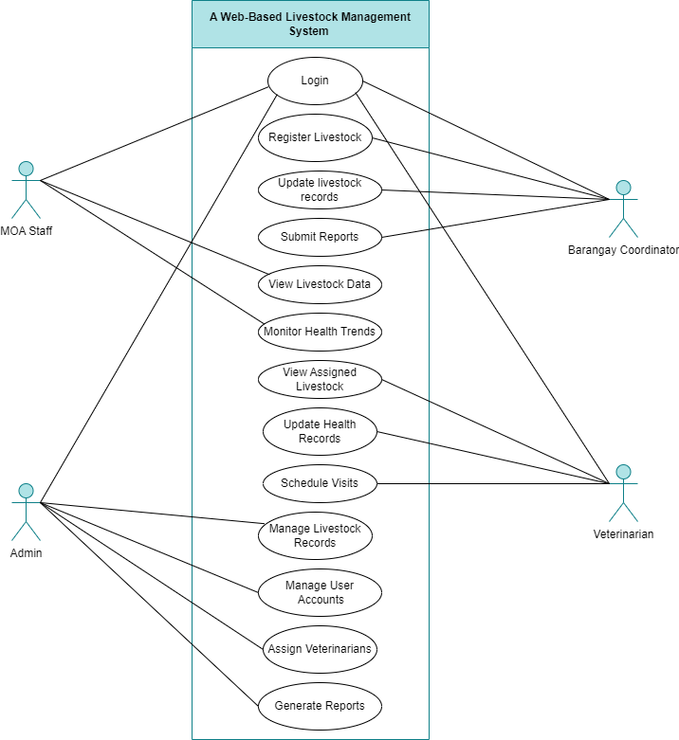

Figure 2. Use Case Diagram

Figure 2 presents the Use Case Diagram of the Web-Based Livestock Management System, highlighting the core functionalities accessible to different user roles: MOA Staff, Barangay Coordinators, Veterinarians, and Admins. All users begin by authenticating through a secure login process. MOA Staff and Barangay Coordinators are responsible for registering and updating livestock profiles, including details such as breed, age, status, and health information. They also have access to real-time livestock data and can generate reports to support informed decision-making. Veterinarians focus on health monitoring, vaccination scheduling, and disease management, ensuring accurate and up-to-date health records for assigned livestock. Admins oversee system operations by managing user accounts, assigning veterinarians, and generating comprehensive reports on livestock productivity, health status, and overall management. The system facilitates continuous health tracking and centralized data access, enabling all roles—except Admins—to monitor livestock information efficiently and contribute to the system’s goal of improving livestock welfare and productivity.

Context Diagram
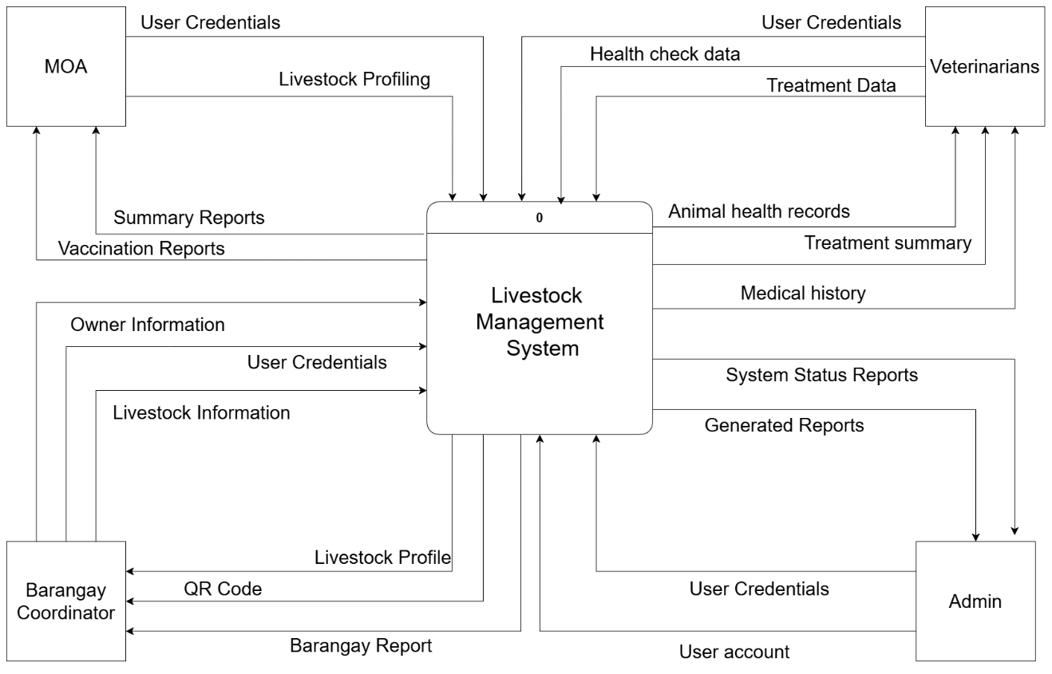
Figure 3. Context Diagram
Figure 3 shows the Context Diagram of the Web-Based Livestock Management System serves as the central platform that facilitates the collection, management, and dissemination of livestock-related information among various external entities. The Municipal Agriculture Office (MOA) interacts with the system by providing user credentials and livestock profiling data, and in return, receives summary and vaccination reports, allowing them to oversee livestock records and monitor health and vaccination status. Veterinarians use the system to input health check data and treatment records, and they access organized animal health records, treatment summaries, and medical histories, ensuring accurate monitoring and management of livestock health. Barangay Coordinators contribute owner information, livestock details, and login credentials, while receiving detailed livestock profiles, QR codes for identification, and summarized barangay reports, supporting local management and tracking of livestock. Meanwhile, the Admin oversees system operations by managing user accounts, inputting account information, and monitoring system performance, receiving status updates and generated reports to ensure smooth operation of all modules. Overall, the Livestock Management System acts as a hub for continuous data exchange, enabling all entities to efficiently input, track, and retrieve information for effective livestock monitoring, health management, and reporting.

Data Flow Diagram
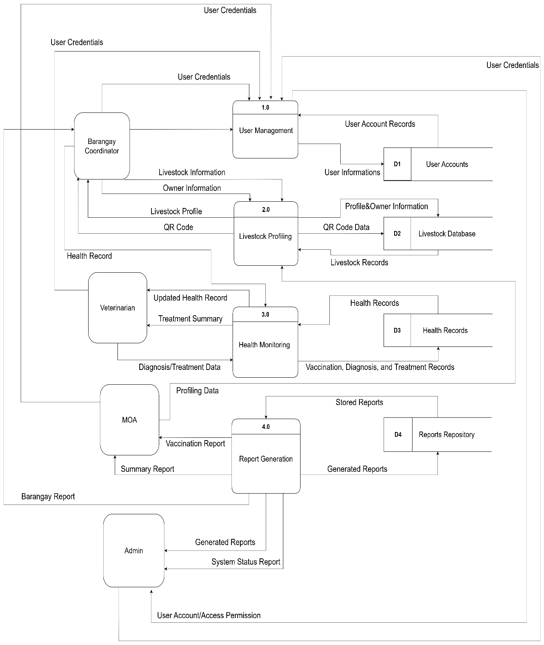
Figure 4. Data Flow Diagram Level 1

Figure 4 shows the Level 1 Data Flow Diagram (DFD) for the Web-Based Livestock Management System is designed to facilitate efficient interaction between various external entities, namely the Barangay Coordinator, Veterinarian, Municipal Agriculture Office (MOA), and system Administrator, through four primary processes: User Management, Livestock Profiling, Health Monitoring, and Report Generation. The User Management process is responsible for the creation, verification, and administration of user accounts, wherein external entities provide their credentials for system access. These credentials are securely stored in the User Accounts database, and appropriate access permissions are granted based on user roles. The Livestock Profiling process enables the Barangay Coordinator to submit detailed livestock information and owner data, which are stored in the Livestock Database. The system subsequently generates comprehensive livestock profiles and QR codes for identification and tracking, thereby supporting effective local livestock management. The Health Monitoring process allows veterinarians to input and maintain livestock health records and treatment data, which are stored in the Health Records database. This process ensures that updated health summaries and treatment reports are readily available, supporting continuous monitoring of animal health, including vaccination, diagnosis, and treatment histories. Finally, the Report Generation process consolidates data from all system modules to produce vaccination reports, summary reports, and other generated reports, which are stored in the Reports Repository. The MOA submits profiling data to facilitate report generation, while the Administrator receives system status and performance reports for oversight and decision-making. Overall, the Livestock Management System functions as a centralized hub, processing inputs from all external entities and providing structured outputs, such as livestock profiles, QR codes, health summaries, and comprehensive reports, thereby ensuring accurate, secure, and efficient livestock management for all stakeholders.

Existing Process Swimlane
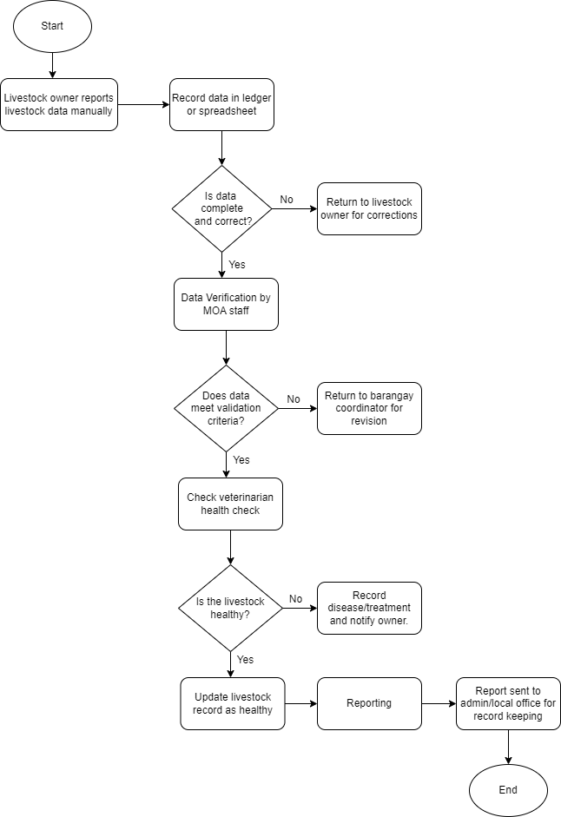
Figure 5. Existing Process/Flow

Figure 5 Existing Process Flow for livestock data management begins when the livestock owner manually reports the necessary information to the barangay coordinator or MOA staff. The reported details are then recorded in a ledger or spreadsheet for documentation. Once recorded, the data is reviewed to check if it is complete and correct. If errors or missing details are found, the information is returned to the livestock owner for correction; otherwise, it proceeds to the next stage. The Municipal Agriculture Office (MOA) staff then verifies the data to ensure that it meets the required validation criteria. Should the data fail this validation, it is returned to the barangay coordinator for revision. If it passes, the process continues with a health check conducted by the veterinarian. During this stage, the veterinarian determines whether the livestock is healthy. If the animal shows signs of illness, the veterinarian records the disease, prescribes treatment, and notifies the owner accordingly. If the livestock is healthy, the record is updated to reflect its status. Afterward, a formal report is prepared and forwarded to the administrator or local office for record-keeping. This process concludes once the report has been properly submitted and stored. Overall, the manual system ensures data accuracy and livestock health monitoring but is often time-consuming due to repetitive verification and corrections.

Process Swimlane
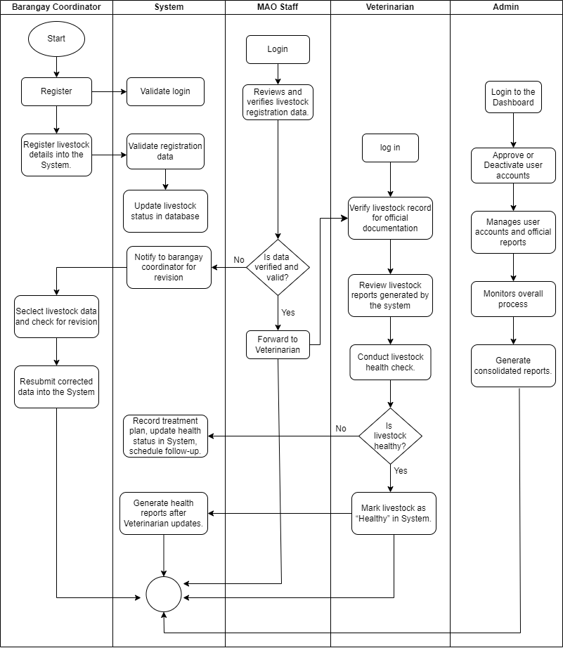
Figure 6. Process Swimlane
Table 6 presents the New Process Swimlane for the proposed Web-Based Livestock Management System. The diagram outlines the workflow involving the Barangay Coordinator, the System, the Municipal Agriculture Office (MOA) Staff, the Veterinarian, and the Administrator. It illustrates how responsibilities are divided, how decisions are made, and how processes are aligned to improve efficiency and accuracy in livestock management. The process begins with the Barangay Coordinator, who registers livestock details into the system. If the data is incomplete or incorrect, the system notifies the coordinator to revise and resubmit the information. The System then validates the registration, updates the livestock database, and forwards the verified data to the MOA Staff. At this stage, a decision is made: invalid records are returned for correction, while valid records proceed to the Veterinarian. The Veterinarian reviews the record and conducts a health assessment. If the livestock is found unhealthy, a treatment plan is encoded, the health status is updated in the system, and a follow-up is scheduled. If healthy, the livestock is marked accordingly, and the system generates an updated health report. The Administrator manages user accounts, monitors system activities, and generates consolidated reports, ensuring accountability and data integrity throughout the process.

Entity-Relationship Diagram

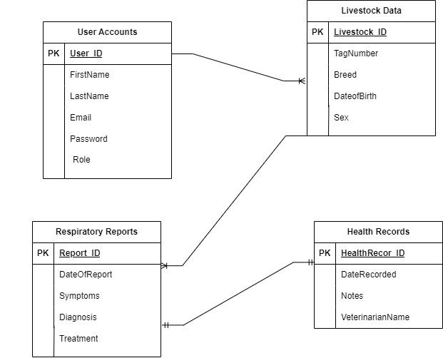
Figure 7. Entity-Relationship Diagram
Table 7 shows Entity Relationship Diagram for A Web-Based Livestock Management System shows how the system’s data is organized and connected. It includes main entities like Users, Livestock Data, Health Records, and Reports, all linked to keep data flowing smoothly between different parts of the system. The Users entity is responsible for managing the accounts and roles of system stakeholders, including administrators, agriculture officers, veterinarians, and barangay coordinators. It ensures secure authentication, proper authorization, and controlled access to system functionalities based on designated roles. The Livestock Data entity encompasses detailed information regarding the livestock population, such as species, breed, age, ownership, and other profiling attributes vital for systematic monitoring and informed decision-making. The Health Records entity is directly associated with the Livestock Data, maintaining comprehensive records of medical treatments, vaccinations, disease incidents, and veterinary interventions to support effective health management. The Reports entity, on the other hand, consolidates information from various modules, generating structured summaries, analytical insights, and performance evaluations that serve as essential tools for policy development, program assessment, and strategic planning.

System Architecture
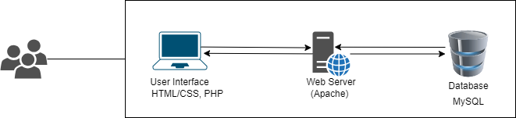
Figure 8. System Architecture

Figure 8 shows the System Architecture of the proposed Web-Based Livestock Management System. The architecture illustrates how the different components of the system interact to provide an efficient and reliable platform for livestock data management. This diagram shows a basic setup for a web based with a client-server system. Users access the app using a web interface made with technologies like HTML, CSS, and PHP . They send their inputs through this interface, which then communicates with the web server, shown here as Apache. The web server processes the requests by running scripts in languages like PHP and talks to the database, MySQL, to get or store data. The database keeps all the information safe and organized. After the server finishes processing, it sends the response back to the user through the web interface. This setup is called a three-tier system because it separates the user interface, the server processing, and the data storage, making the app easier to manage and secure.

Storyboard
This figure shows the user access screen where individuals log in to the ALAGANG BARAS system to begin using its features.
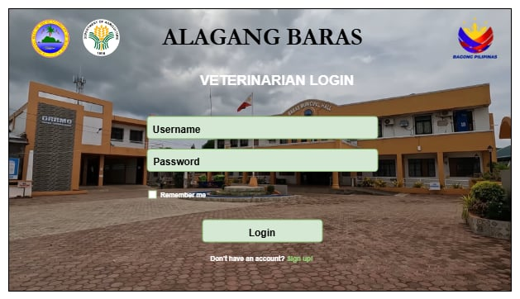
Figure 9. Login Page for Veterinarian
The Veterinarian Login Page provides secure access for authorized veterinarians to manage livestock health records. By requiring login credentials, it ensures data confidentiality while allowing veterinarians to update profiles, record consultations, and monitor animal health.
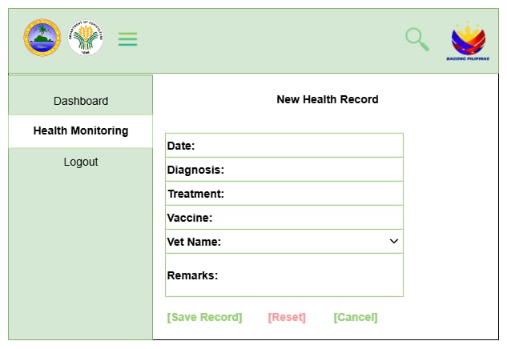
Figure 10. New Health Record
Figure 10 shows the New Health Record of the Alagang Baras Web-Based Livestock Management System. This part of the system is used to record and manage the health information of livestock in a simple and organized way. It has fields where users can enter important details like the date of check-up, diagnosis, treatment, vaccine given, the name of the veterinarian, and any remarks. It also has buttons such as Save Record to store the data, Reset to clear the form, and Cancel to go back without saving. This module helps make health recording easier because it allows veterinarians and staff to keep accurate and updated records, which is important in preventing diseases, giving the right treatment, and managing livestock more effectively.

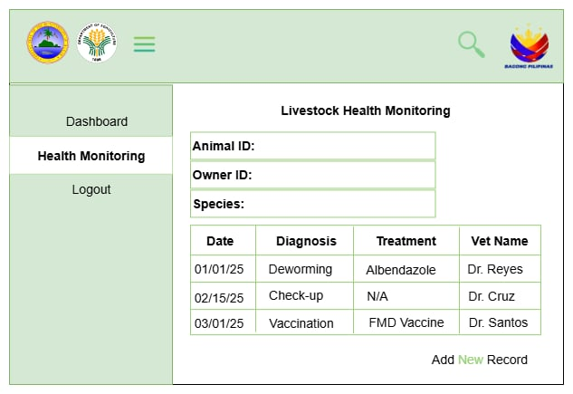
Figure 11. Livestock Health Monitoring
Figure 11 shows the Livestock Health Monitoring of the Web-Based Livestock Management System. It has fields for Animal ID, Owner ID, and Species to identify the livestock, and a table that shows the date, diagnosis, treatment, and veterinarian in charge. Records like deworming, check-ups, and vaccinations are displayed for easy tracking. There is also an option to add a new record so the health status of animals can be updated. This helps in keeping track of treatments and makes livestock management easier and more organized.

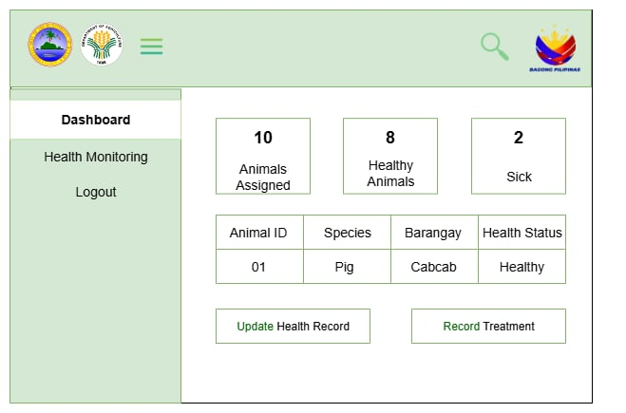
Figure 12. Dashboard Page for Veterinarian
Figure 12 shows the Dashboard Page for Veterinarian in the Alagang Baras. This page gives an overview of livestock health by displaying the number of animals assigned, how many are healthy, and how many are sick. It also lists important details such as Animal ID, Species, Barangay, and Health Status for easier monitoring. The page includes options to Update Health Record and Record Treatment, allowing veterinarians to manage and track the health condition of animals efficiently. This dashboard helps vets quickly see the overall status of livestock and take immediate action when needed.
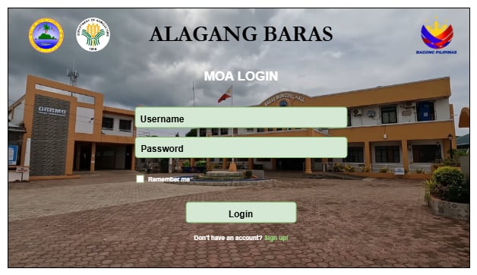
Figure 13 MOA Staff Login Page
Figure 13 shows MOA Staff Login Page is designed to provide authorized staff members of the Municipal Agriculture Office with secure access to the system. Through this page, staff can log in using their credentials to manage livestock records, verify registrations, and assist in monitoring and updating relevant data. This ensures that only verified personnel can handle sensitive information, promoting data accuracy, security, and efficient coordination within the livestock management process.

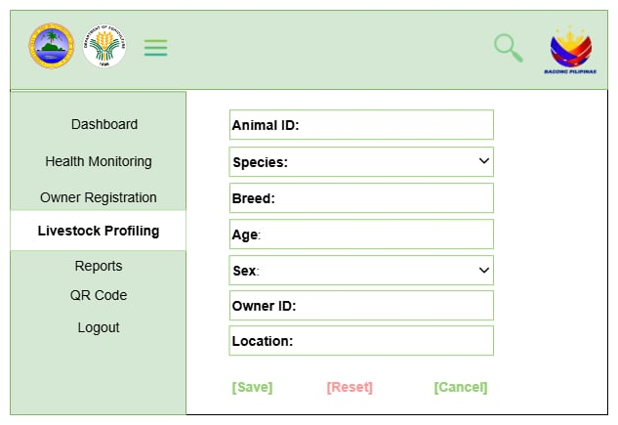
Figure 14. Update Livestock Profiling
Figure 14. Update Livestock Profiling shows the digital form used to update important animal details such as ID, species, breed, and owner information. This feature ensures that existing records remain accurate and current, while still being connected to the system’s health monitoring, registration, and QR code tracking, which contribute to more efficient and reliable livestock management.
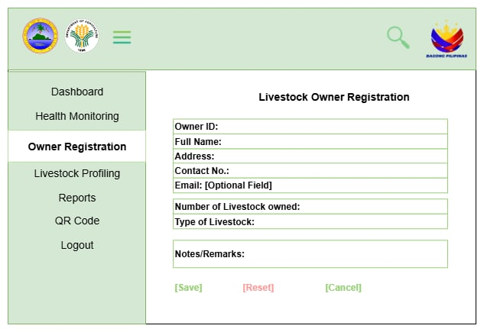
Figure 15. Manage Livestock Owner Registration
Figure 15. Manage Livestock Owner Registration presents the module for recording and updating essential information about livestock owners and their animals. This feature enhances traceability and supports health monitoring, disease control, and agricultural planning by ensuring accurate and organized data within a streamlined digital system.

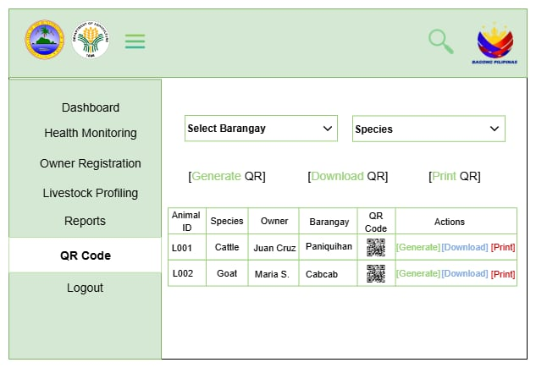
Figure 16. QR Code for Livestock
Figure 16 shows the QR Code feature allows quick identification and tracking of livestock by linking unique codes to each animal’s profile, improving traceability, record-keeping, and access to health and ownership data.
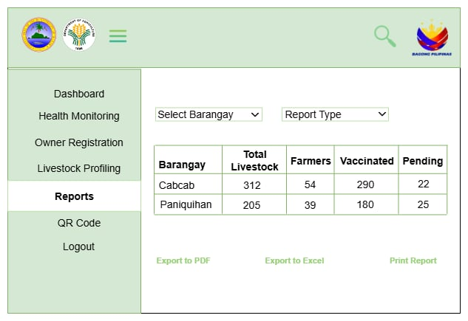
Figure 17. Reports
Figure 17 shows the Reports section summarizing livestock data by barangay, including totals, farmer count, and vaccination status. It supports filtering and exporting, aiding efficient monitoring and management.
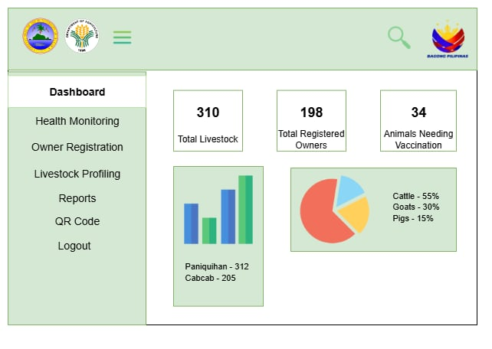
Figure 18. Dashboard for MOA Staff
Figure 18 shows the MOA staff dashboard, offering a centralized view of livestock data with features like health monitoring, registration, profiling, reports, and QR code access. It displays key stats—total livestock, registered owners, and animals needing vaccination—alongside visual charts comparing barangay livestock counts and species distribution. This aids efficient oversight and resource planning.
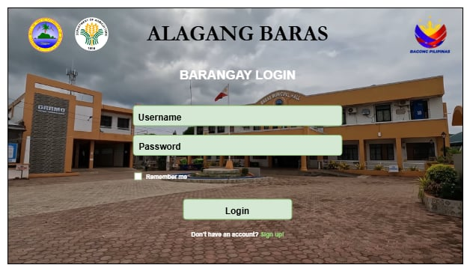
Figure 19. Barangay Coordinator Login Page
Figure 19 shows the Barangay Coordinator Login Page allows designated coordinators to securely access the system and manage livestock data within their barangay. Through this page, they can log in using their credentials to update records, verify livestock ownership, and oversee information submitted by local farmers. This feature ensures accurate data collection at the community level and supports efficient coordination with the Municipal Agriculture Office and veterinarians.
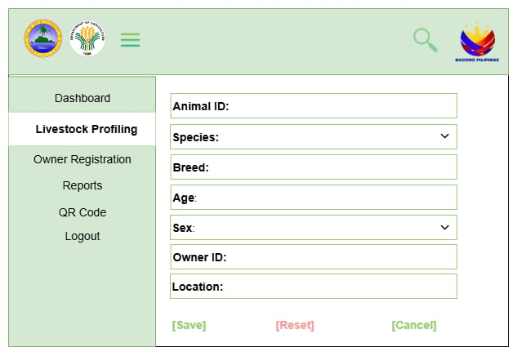
Figure 20. Add Livestock Profiling
Figure 20 shows Add Livestock Profiling shows the form used to register new livestock by entering details such as ID, species, breed, and owner. This helps keep records organized and supports accurate monitoring and management of animals.
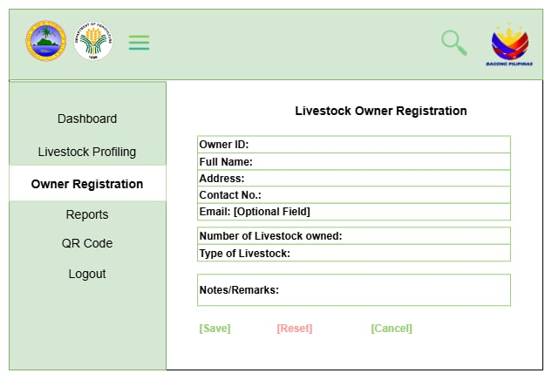
Figure 21. Owner Registration Form
Figure 21 shows Owner Registration Form displays the digital form used to record essential details of livestock owners. This feature ensures accurate registration, making it easier to track ownership and support efficient livestock management.
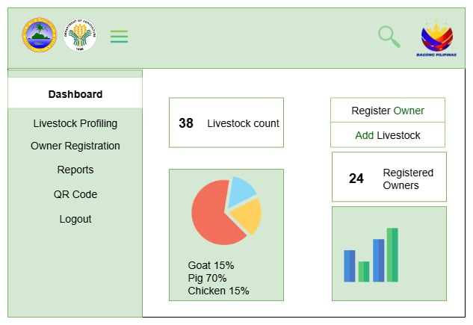
Figure 22. Dashboard for Barangay Coordinnator
Figure 22 Dashboard for Barangay Coordinator shows the main page where the coordinator can view and manage livestock records in their barangay. It displays updates, registrations, and reports, making it easier to monitor and coordinate with the Municipal Agriculture Office.
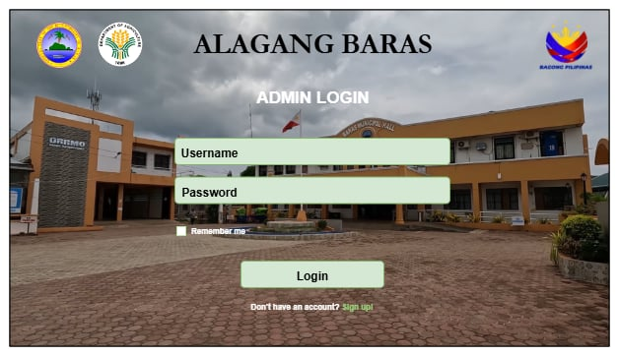
Figure 23. Log in page for Admin
Figure 23. Log in Page for Admin shows the page where the admin enters their account credentials to access the system. Through this, the admin can securely manage users, records, and overall system settings.

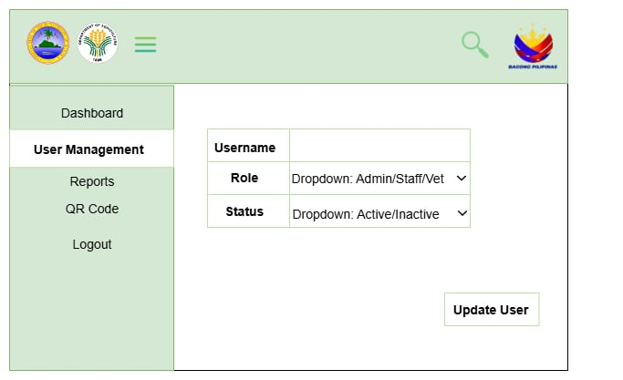
Figure 24. User Management Section
Figure 24 shows the User Management section allows admins to update user roles, account status, and credentials, ensuring secure access and organized control within the livestock system. It includes quick navigation to key features for efficient administration.
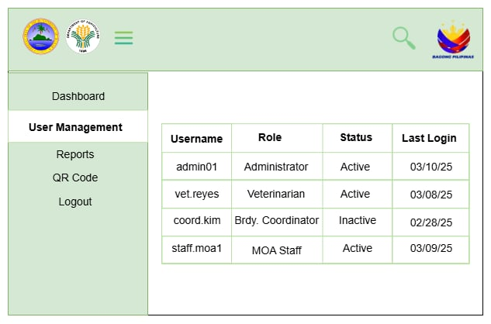
Figure 25 User Management Interface
Figure 25 shows the User Management interface of the system, used to oversee user roles and access within an agricultural or government platform. While the main table lists users by username, role (Administrator, Veterinarian, Barangay Coordinator, MOA Staff), status (Active or Inactive), and last login date. This setup helps administrators monitor user activity and maintain secure, role-based access across the system.
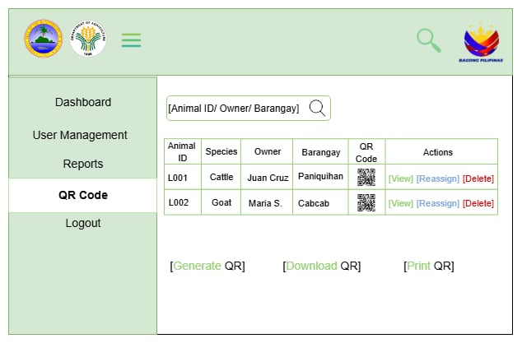
Figure 26 QR Code Management Interface
Figure 26 shows the QR Code management interface of a livestock tracking system, used by local government staff to monitor and organize animal records. It features a sidebar with navigation options and a searchable table listing animals by ID, species, owner, barangay, and QR code. Each entry includes actions to view, reassign, or delete, while buttons below the table allow users to generate, download, or print QR codes. This system enhances traceability and simplifies livestock identification across barangays.
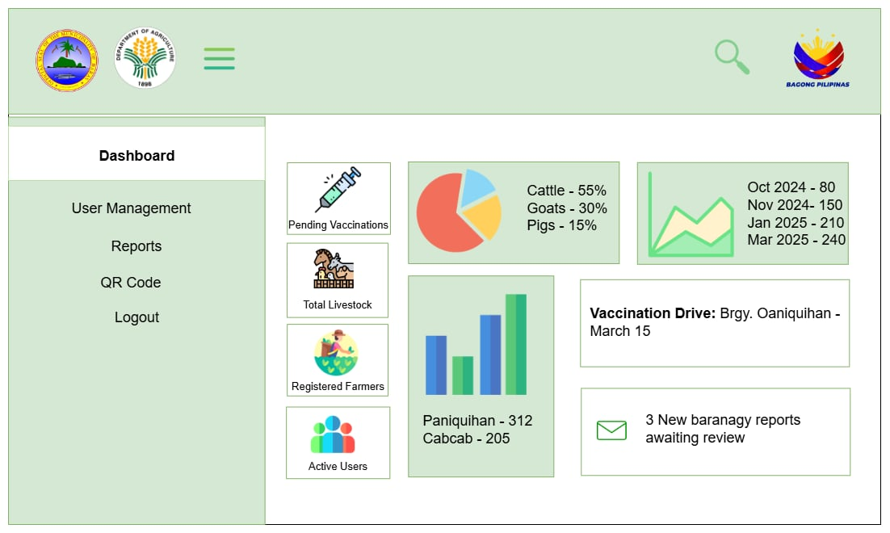
Figure 27 Admin Dashboard
Figure 27 shows Admin Dashboard provides administrators with an overview of livestock and agricultural data. It shows key details such as livestock distribution, pending vaccinations, registered farmers, and active users. Charts display livestock counts per barangay, while notifications highlight new reports for review.

Development and Testing
Software Development Method

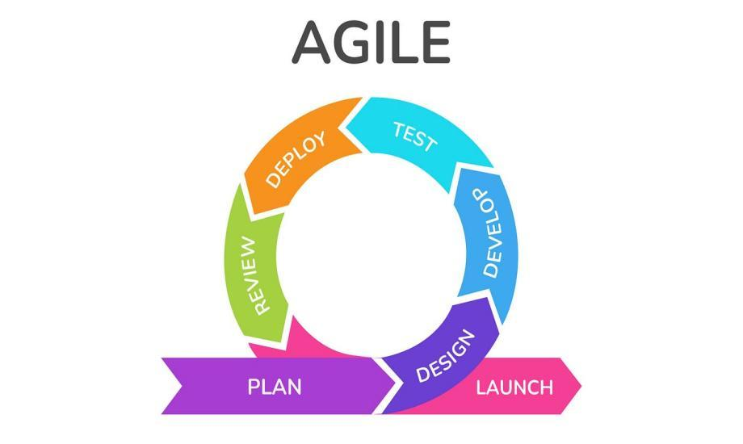
ImageSource:https://www.google.com/url?sa=i&url=https%3A%2F%2Fmedium.com%2Fagileinsider%2Fhow-to-create-a-business-requirements-document-in-agile.
Figure 24. Agile Methodology
The Agile process in this study included the following main phases: Planning, Design, Development (Sprint Cycles), Testing, and Deployment.
Planning Phase
In this Planning Phase, the development team collaborates closely with key stakeholders, including the Municipal Agriculture Office staff, veterinarians, barangay coordinators, and system administrators, to thoroughly assess and identify the specific requirements of the livestock management system. This phase establishes the foundation of the project by clearly defining its overarching objectives, such as livestock profiling, health monitoring, and report generation. A comprehensive product backlog is then created, which serves as a prioritized list of features and functions to be developed. At this stage, user roles and responsibilities are also determined to ensure that all system interactions are properly addressed. Furthermore, the team formulates a definition of done, which provides clear criteria for determining when a feature can be considered complete. To guide development progress, an initial project roadmap and release plan are also prepared, offering a structured timeline for implementation and delivery.

Requirements Phase
The Requirements Phase, the needs of stakeholders are systematically translated into user stories that outline how each role within the system is expected to interact with its functionalities. For instance, a veterinarian may require the capability to record livestock health conditions in order to monitor treatment progress effectively. These user stories are further refined into smaller, manageable tasks, which are then incorporated into the product backlog. To ensure proper prioritization and planning, sprint planning meetings are conducted to determine the specific features to be developed during the upcoming sprint cycle. At this stage, acceptance criteria are also established to provide measurable benchmarks for evaluating whether the developed functionalities meet the intended requirements. In addition, wireframes or mockups may be produced to serve as visual representations of the proposed system design, thereby facilitating clearer communication and alignment between developers and stakeholders.
Design & Development Phase (Sprint Cycles)
The Design and Development Phase, user interface (UI) and user experience (UX) prototypes are designed to illustrate the functionality and layout of the system modules, which include livestock profiling, health monitoring, reporting, and analytics. The development process follows an iterative approach and is structured into sprints, typically lasting two to four weeks. Each sprint focuses on the implementation of specific system features; for example, the initial sprint emphasizes user authentication and role management, while subsequent sprints address livestock profiling, health monitoring, and the analytics dashboard. To ensure systematic integration of updates and minimize potential errors, continuous integration is employed, allowing newly developed code to be merged regularly into the main system. Daily stand-up meetings are conducted to monitor progress, address potential challenges, and establish tasks for the succeeding day. Additionally, project management tools such as Kanban or Scrum boards are utilized to organize and track tasks, thereby promoting transparency and efficiency throughout the development cycle.
Testing Phase
In this Phase, the system is subjected to a series of validation procedures to ensure its functionality, reliability, and alignment with user requirements. Unit testing is initially conducted to evaluate the performance of individual modules, verifying that each component functions as intended. This is followed by integration testing, which examines the interaction between modules to confirm that they operate seamlessly as a unified system. Furthermore, user acceptance testing (UAT) is carried out by end-users, including staff, veterinarians, and barangay coordinators, to assess whether the system adequately addresses their operational needs and expectations. Any errors, bugs, or issues identified during testing are documented in the product backlog, prioritized based on their impact, and subsequently resolved within the sprint cycle. This iterative approach ensures that system refinements are continuously implemented, thereby enhancing the overall quality and usability of the application.
Deployment Phase
The Deployment Phase, the system is released for practical use through a structured and gradual implementation process. Initially, the system is deployed in a staging environment to allow for controlled trial runs and to identify any remaining issues prior to official use. This is followed by pilot testing in selected barangays, which serves to validate the system’s effectiveness in real-world conditions before a full-scale rollout. To ensure smooth adoption, user training sessions are conducted to familiarize stakeholders—including staff, veterinarians, and barangay coordinators—with the system’s core functionalities. Feedback obtained during this stage is systematically collected and analyzed to guide refinements and further improvements. Additionally, comprehensive documentation, such as user manuals and training guides, is developed to provide long-term support and to ensure that users are equipped with the necessary knowledge to operate the system effectively.

Review & Feedback Phase
The Review and Feedback Phase, sprint review meetings are conducted wherein the development team presents and demonstrates the completed system features to stakeholders for evaluation. This process enables stakeholders to provide direct feedback, which is then utilized to refine or enhance the system’s functionalities. Any additional requirements identified during this stage are incorporated into the product backlog to be addressed in future sprints. Furthermore, a sprint retrospective is carried out within the development team to critically reflect on the development process. This activity involves identifying practices that were effective, recognizing challenges encountered, and formulating strategies for improving performance in subsequent sprints. Through this phase, continuous improvement is ensured, both in terms of system quality and team efficiency.
Maintenance & Continuous Improvement Phase
The Maintenance and Continuous Improvement Phase, the long-term sustainability and relevance of the system are ensured through regular monitoring and timely interventions. System performance is continuously observed, and any reported issues are addressed promptly to prevent disruptions in functionality. Updates, patches, and security enhancements are systematically implemented to safeguard data integrity and maintain optimal performance. As stakeholder needs evolve, additional features may be developed to enhance the system’s usefulness, such as the integration of SMS reminders for livestock vaccination schedules. Moreover, continuous user training is provided to accommodate newly assigned staff members and barangay coordinators, thereby ensuring consistent and effective utilization of the system. This phase underscores the importance of adaptability, guaranteeing that the system remains aligned with stakeholder requirements and responsive to the dynamic challenges of livestock management.
Evaluation
The evaluation of ALAGANG BARAS: A Web-Based Livestock Management System for the Office of Agriculture in Baras, Catanduanes aimed to assess the system’s effectiveness, usability, and alignment with project objectives. The Descriptive Survey Method was employed to systematically gather feedback from end-users and stakeholders through questionnaires, interviews, and observations. Questionnaires measured user satisfaction on system functionality, interface design, and overall experience using a Likert scale. Interviews with agricultural staff provided insights into how well the system supports daily operations, while observational sessions allowed real-time assessment of user interaction and ease of navigation. In line with the Agile methodology, the team conducted Sprint Reviews, Retrospectives, and User Acceptance Testing to gather continuous feedback throughout development. These evaluations ensured that each module met user needs and allowed timely improvements.

Data Gathering Procedure
The evaluation of the effectiveness and quality of the proposed system will be carried out through the administration of survey questionnaires to the identified end-users, which include the Municipal Agriculture Office (MOA) staff, veterinarians, barangay coordinators, and the system administrator. The survey instrument will be developed in accordance with the ISO/IEC 25010 software quality standards, which provide a framework for assessing software in terms of functionality, usability, reliability, efficiency, maintainability, and portability. Prior to the full-scale implementation, the system will undergo pilot testing in selected barangays. During this stage, the respondents will be given the opportunity to utilize the system in performing their designated tasks, such as livestock profiling, health monitoring, and report generation. After this hands-on interaction, they will be asked to accomplish the survey questionnaire to formally record their evaluation of the system. The questionnaire will employ a Likert scale format, where respondents will indicate their degree of agreement with a series of statements, ranging from “Strongly Disagree” to “Strongly Agree.” The responses gathered from the survey will be systematically tabulated and subjected to statistical analysis in order to determine the overall performance, acceptability, and effectiveness of the system. The findings will serve as the basis for identifying strengths, addressing areas for improvement, and ensuring that the developed system adequately responds to the operational requirements of its users. This procedure ensures that the system evaluation is comprehensive, evidence-based, and aligned with internationally recognized software quality standards.

Interviews
Structured interviews were conducted with key personnel from the Office of Agriculture, such as livestock technicians, administrative staff, and local agricultural officers. The interviews aimed to gather insights on current practices, challenges in record-keeping and monitoring, and specific requirements for the system. The feedback was used to align system features with actual field operations and user expectations.
Observations
Field observations were carried out to understand the day-to-day operations of the agricultural office, particularly how livestock data is recorded, stored, and retrieved. This helped assess workflow inefficiencies and identify opportunities for automation and process improvement through the system.
Ethical Considerations
All data gathering activities were conducted in accordance with ethical research standards. Permissions were secured from the appropriate authorities, and informed consent was obtained from all participants. Data privacy and confidentiality were strictly maintained, and all collected information was used solely for academic and system development purposes.

Respondents of the Study
This study employed purposive sampling to select respondents from the Office of Agriculture in Baras, Catanduanes, as well as the Barangay Coordinator of Paniquihan. The respondents were chosen based on their direct involvement in livestock monitoring, profiling, and management activities. Specifically, the study included three administrative staff, one Municipal Agriculture Office (MAO) staff, two veterinarians, one barangay coordinator from Paniquihan, and two technical experts. Purposive sampling, as described by Etikan, I. (2016), is a non-probability sampling technique wherein participants are deliberately selected according to their expertise, responsibilities, or knowledge relevant to the study. The inclusion of these respondents was justified by their practical experience in livestock data recording, health monitoring, and decision-making in agricultural operations. Their roles provided the necessary authority, technical competence, and field-level perspective to evaluate the system’s functionality, usability, and relevance. This approach allowed the researchers to obtain in-depth, meaningful feedback from actual system users rather than rely on random sampling, thereby strengthening the study’s validity.

Table 7. Respondents of the Study
Type of Respondent | Total Population | Sample
Administrator (Admin) | 4 | 3
MOA Staff | 1 | 1
Veterinarian | 2 | 2
Barangay Coordinator (Paniquihan) | 1 | 1
Technical Experts | 3 | 2
Total 11 |  | 9

The study’s respondents are key personnel from the Office of Agriculture in Baras and the Barangay Coordinator of Paniquihan. They were purposefully selected to represent the primary users of the proposed system. The group includes three administrative responsible for livestock data entry, system management, and report generation; one Municipal Agriculture Office (MAO) staff overseeing livestock programs and coordination; one barangay coordinator from Paniquihan tasked with grassroots-level livestock profiling and monitoring; two veterinarians providing expertise in livestock health management and disease prevention; and two technical experts with knowledge in system development and implementation. Their active involvement in livestock operations ensures that the feedback they provide is both accurate and aligned with the practical needs of the department and the barangay.

Statistical Tool
The researchers used descriptive statistical tool in which allows review sets of data and extract important information. Since the data gathered by a questionnaire will be measure by the use of descriptive statistical tool and frequency count to look for the mean on the effectiveness of making the system, either it will be successful or not.
The formula in looking the mean as stated below:
Arithmetic mean ($\underline{x}$) = $\sum_{i}^{n}{}= 1 x i$
_______________
$n$
= Individual data points (e.g., Likert-scale scores for the system evaluation)

= Total number of data points

The researchers used 5 point Likert scale is used with the remark of excellent, very satisfactory, staisfactory, fair, and poor.

Table 6. Likert Scale
Range | Quantitative Equivalent | Qualitative Equivalent
4.20 - 5.00 | 5 | Excellent
3.40 - 4.19 | 4 | Very Satisfactory
2.60 - 3.39 | 3 | Satisfactory
1.80 - 2.59 | 2 | Fair
1.00 - 1.79 | 1 | Poor

Table 6. shows the interpretation and the evaluation, the researchers will use the 9 parameters of ISO/IEC 25010 standards using the purposive sampling wherein the evaluation results were determined using the mean, and to assess the effectiveness of the application, mean scores were calculated and then grouped according to the same criteria. In addition, the researchers will also apply his process to find the sample of the evaluators.
The systems will be evaluate in accordance to the ISO/IEC 25010 in terms of Functional Suitability, Performance Efficiency, Compatibility, Interaction Capability, Reliability, Security, Maintainability, Flexibility, and Safety.

REFERENCES

Books
Ghosh, N. (2019). Livestock production management. PHI Learning Pvt. Ltd..
Gadekar, B. B. (2021). Livestock And Agricultural Development. Lulu Publication.
Ghosh, N. (2019). Livestock production management. PHI Learning Pvt.

Journals/Conferences
Terence, S., Immaculate, J., Raj, A., & Nadarajan, J. (2024). Systematic Review sa Internet of Things sa Smart Livestock Management Systems. Sustainability
Zaabar, L. S., Yacob, A. A., Nathan, D. K., Yip, E. W. H., & Razali, N. A. M. (2025). A Review of Livestock Smart Farming for Sustainable Food Security. JOIV: International Journal on Informatics Visualization, 9(2), 728-736.
Bertalanffy, L. (1968). General System Theory: Foundations, Development, Applications. New York: George Braziller.
Panda, S. S., Terrill, T. H., Siddique, A., Mahapatra, A. K., Morgan, E. R., Pech-Cervantes, A. A., & Van Wyk, J. A. (2024). Development of a decision support system for animal health management using geo-information technology: a novel approach to precision livestock management. Agriculture, 14(5), 696.
Ariff, MH, Ismarani, I., & Shamsuddin, N. (2014, Disyembre). RFID based systematic livestock health management system. Noong 2014 IEEE Conference on Systems, Process and Control (ICSPC 2014). IEEE.
Yang, Y., Ren, R., & Johnson, P. M. (2020). VetLink: A livestock disease-management system. IEEE Potentials,.
Jiang, J. A., Lin, T. S., Wang, C. H., Liao, M. S., Chou, C. Y., & Chen, C. T. (2017, December). Integration of an automatic agricultural and livestock production management system and an agriculture and food traceability system based on the Internet of Things technology. In 2017 Eleventh International Conference on Sensing Technology (ICST). IEEE.
Mammi, HK (2025). Stray Rescue Management System (SRMS). International Journal of Innovative Computing , 15 (1), 139-144.
Saravanan, K., & Saranya, S. (2017). An integrated animal husbandry livestock management system. Journal of Advances in Chemistry,

Websites
Radotra, S. (2022). Livestock health and management. https://doi.org/10.59317/9789394490277
Review of Fernandez de Vera et al. 2016. (2016). https://doi.org/10.5194/hess-2016-79-rc1
Biggs, A., & Smith, J. (2023). Digital animal health records: Experiences and practice. Frontiers in Veterinary Science, 10, 1182117. https://doi.org/10.3389/fvets.2023.1182117
FAO. (2023). The role of digital technologies in livestock traceability and trade. Food and Agriculture Organization of the United Nations. https://www.fao.org
Frontiers. (2023). Data integration dashboard for sustainable agriculture: Case study in Senegal. Frontiers in Sustainable Food Systems, 7, 112567. https://doi.org/[details pending]
Frontiers in Veterinary Science. (2023). Applications of livestock monitoring devices and machine learning. Frontiers in Veterinary Science, 10, 1127345. https://doi.org/10.3389/fvets.2023.1127345
Keating, B. A., Carberry, P. S., & Jones, J. W. (2019). A review of visualisations in agricultural decision support systems. Computers and Electronics in Agriculture, 162, 388–402. https://doi.org/10.1016/j.compag.2019.04.003
Mylan, J., & Turner, K. (2023). Digital documentation of farm treatments: Solutions and prospects. Science of The Total Environment, 859, 160056. https://doi.org/10.1016/j.scitotenv.2022.160056
PLOS. (2024). Digital livestock technologies as boundary objects in practice. PLOS ONE, 19(3), e0291234. https://doi.org/[details pending]
Smith, R., & Brown, T. (2022). Deployment of an intelligent and secure cattle health monitoring system. Procedia Computer Science, 200, 456–463. https://doi.org/[details pending]
USDA. (2023). LTAR and DAWN dashboards for agricultural decision-making. United States Department of Agriculture. https://www.usda.gov
Workneh, A., Tulu, T., & Abebe, G. (2022). Electronic livestock health recording systems for disease surveillance in Ethiopia. In Proceedings of the International Conference on E-Health Systems. https://doi.org/[details pending]

S. (2022). Kalusugan at pamamahala ng mga hayop.

